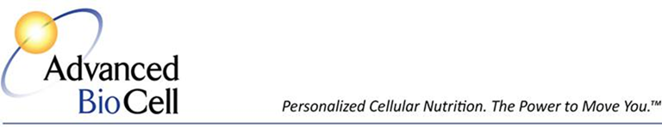
L-Arginine: The Nobel Amino Acid Miracle Molecule
L-arginine is now recognized as a life saving molecule known as Nitric Oxide. Nitric Oxide is naturally created in the body and with time and age is depleted - the body makes less with aging.
Your kidney can only produce so much L-arginine at a time because of the amino acid L-citrulline which converts into L-arginine and can only be produced so fast. With a burn, infection or injury, your body can't produce enough L-arginine from L-citrulline. As a result, we're totally dependent on our diet to produce L-arginine. The problem is that most people don't eat the right foods or the right combination of foods that will make the most
L-arginine so they are still short. This is where supplementation becomes crucial.
In 1992, Science Magazine, which is considered the premier scientific journal in the world, published by the American Association for Scientists, published an article referring to
L-arginine as 'the miracle molecule' and 'the molecule of the year.' The reason was due to the research coming out from the University of Texas, the State University of New York and UCLA at that time that was starting to show that L-arginine was absolutely essential for cardiovascular function. It is actually a gas that circulates throughout the body that increases the body's abilities to respond to repairing tissue. It makes everything happen faster for this function.
The faster a tow truck can get to an accident scene, the quicker the car can be removed from blocking traffic and be repaired. L-arginine stimulates the body's ability to move molecules through a process called 'signaling.' This was the great breakthrough in the research: the body was actually sending signals through different cells and the cells were now responding the way they were supposed to whether they were going to the immune system or replacing or repairing damaged cells.
As a result of this research, in 1998 all 3 of these doctors from the different universities won the Nobel Prize in medicine and physiology. That began the process where companies began to produce a product with L-arginine that would increase nitric oxide, the gas that delivers increased oxygen to the cells to facilitate normal healing.
The benefits of L-arginine are highlighted by its ability to get rid of a waste product called ammonia. Ammonia is toxic in the human body. We are constantly creating and breaking down tissue. When tissue breaks down, we create nitrogen. Nitrogen combines with hydrogen to form ammonia which the body must get rid of on a regular basis. L-arginine helps to get rid of that waste product. Without this process, we would become toxic in a way that could eventually lead to death.
L-arginine helps the body to make 3 other amino acids: creatine, which provides muscle energy and nervous system support; L-proline, important for wound healing and the synthesis of collagen (the substance that gets rid of skin wrinkles, supports hair growth and keeps joints healthy); and L-glutamine, an excitatory amino acid which is very involved in making energy and supporting cognitive brain function (learning, memory, logic, reasoning, computation, scientific inquiry).
Another fascinating thing about L-arginine is its ability to stimulate Human Growth Hormone (HGH) and L-prolactin. These hormones support aging and longevity.
In its support of the production of nitric oxide, L-arginine plays a significant role in sexual function as it dilates micro vessels. When this occurs in the sexual organs, there is increasing sexual arousal and stimulation because the blood vessels are relaxed and the blood flow increases. All the sexual organs and areas can become highly stimulated. This is why
L-arginine is associated with sexual responsiveness for both men and women.
Advanced BioCell distributes the highest quality L-arginine supplement available.
Ask your body what it needs to move well, heal and feel better. We'll tell you what it says.

Advanced BioCell
Personal Cellular Health. The Power to Move You.™
310.550.6767

"The more good things you do, the more good things you do."
- Dr. Bruce Boyd, Professor of Psychiatry, Northwestern University

© Advanced BioCell 2015

